COOLER TRACKING SYSTEM (CTS) DEPLOYMENT
STANDARD OPERATING PROCEDURES

What is CTS (Cooler Tracking System) and Purpose
The Cooler Tracking System (CTS) is an integrated, end-to-end digital platform designed to manage, monitor, and control the entire lifecycle of coolers and other retail assets. It enables organizations to systematically handle everything from asset requesting, approvals, allocation, dispatch, delivery, installation, and final closure—all within a single centralized system.
The purpose of CTS is to ensure that every cooler deployed in the market is traceable, accountable, fully documented, and compliant with internal and financial guidelines.
This is accomplished through a multi-stakeholder digital workflow, where each participant performs a clearly defined role at specific stages.
End-to-End Lifecycle Flow
The system follows a structured, sequential workflow:
Asset Request → Approvals → Service Provider Allocation → Delivery → Installation → Closure
Each stage is controlled by system validations, mandatory documentation, and user accountability.

Centralized Collaboration Ecosystem
The CTS brings together multiple stakeholders:
FOS/CSO → ASE/ASM → Finance Team → BPO Customer → CDE → Service Provider → BPO CCO → BPO Delivery → Service Provider → Delivery → Installation → BPO Verifier (Document Verifier).
Each role contributes to a specific phase, forming a tightly coupled chain of activities ensuring complete control and visibility.
User Role and Responsibilities

1. FOS/CSO (Field Officer / Customer Sales Officer)
The FOS/CSO is responsible for initiating the cooler request on behalf of the retailer. They identify the retailer’s, onboard the retailer into the system if retailer not onboarded, and submit the cooler request with all required details and documents. As the first point of contact, they represent the retailer in the system and ensure all initial information is accurate before the request moves forward for approval.

2. ASE (Area Sales Executive) / ASM (Area Sales Manager)
The ASE / ASM acts as the approver who reviews and validates the cooler request raised by the FOS/CSO. They check whether the retailer is eligible, whether the business need is genuine, and whether the asset type requested is appropriate. ASE / ASM ensures that only legitimate and accurate requests are passed further into the workflow and may modify asset details before approving. Their role ensures a level of control and oversight, maintaining accuracy and preventing errors or misuse at the early stage of the process.

3. BPO Customer / Finance Team
The BPO Customer Team is responsible for managing the financial, compliance, and data governance aspects of the cooler request lifecycle. Their responsibilities include validating all uploaded documents to ensure completeness, accuracy, and compliance with company and regulatory standards; monitoring request quality and addressing discrepancies to maintain process integrity; providing backend operational support to resolve bottlenecks and ensure timely processing; and creating SAP customer codes whenever required to facilitate seamless request execution. Through these functions, the BPO Customer Team ensures that every cooler request adheres to financial controls, compliance requirements, and master data quality standards before advancing to the next stage of the workflow.

4. CDE (Central Distribution Executive)
The CDE is responsible for managing the operational execution of approved cooler requests. They review BPO Customer approved requests, assign the appropriate service provider for delivery and installation, and update crucial information such as asset type or service provider mapping. The CDE also uploads GRN and cooler equipment details, ensuring that the correct asset is allocated for each retailer request.

5. Service Provider
The Service Provider is responsible for end-to-end execution of cooler deployment, managing both the operational and system-driven activities. Once the request is allocated by the CDE, the Service Provider assigns the appropriate asset ID, sends request to CCO creator for creating CCO number in SAP, and ensures that all system prerequisites are completed before the request moves forward. They also coordinate all field-level tasks by assigning the delivery person and service engineer, planning delivery routes, managing equipment availability, and scheduling installation activities. During execution, they oversee the accurate movement of the cooler, maintain equipment details, and ensure the entire delivery and installation process is handled smoothly. After installation, the Service Provider collects the signed agreement from the delivery agent, uploads it into the system, and completes the final closure of the request. Their role ensures that both system requirements and field operations are executed seamlessly from allocation to closure.

6. BPO CCO
The BPO CCO team completes the compliance stage of the cooler request by creating the CCO number in SAP based on the asset allocation and asset ID assigned by the Service Provider. Once the service provider maps the equipment and provides the necessary asset details, the BPO CCO team uses this information to generate the correct CCO number in SAP and then updates it back into the request. Their role ensures that the compliance and SAP-related steps are accurately completed so the cooler request can progress smoothly toward final closure without any data mismatches or process delays.

7. BPO Delivery
The BPO Delivery team is responsible for completing all delivery-related system activities after the CCO details are updated. Based on the asset allocation and the request status, they create the delivery challan and e-way bill required for the physical movement of the cooler. They upload these documents into the portal to keep the request records accurate and updated. As part of their workflow, they also enter key logistics information such as PGI (Post Goods Issue) details and shipment details, ensuring that the system reflects the correct movement of the asset from warehouse to retailer. Through these responsibilities, the BPO Delivery team ensures that the cooler is fully compliant for dispatch and that all logistical and SAP-related delivery records are correctly maintained before the asset reaches the field execution stage.

8. Delivery Person
The Delivery Person is responsible for physically delivering the cooler to the retailer. They receive the delivery assignment through the system, pick up the correct cooler from the warehouse, deliver it to the retailer’s location, and update the system with proof of delivery. They also complete OTP verification with the retailer to confirm accurate and successful delivery.

9. Service Engineer
The Service Engineer is responsible for installing the cooler at the retailer outlet after delivery. They receive installation tasks from the service provider, visit the location, scan the QR code on the cooler to verify equipment identity, and complete the installation process. Their role ensures the cooler is correctly set up, activated, and ready for use at the retailer store.

10. BPO Verifier
The BPO Verifier is responsible for completing the final verification stage of the cooler deployment process. Once the retailer hands over the signed agreement to the Delivery Person and it reaches the Service Provider, the document is uploaded into the system as part of the closure steps. The BPO Verifier reviews this uploaded agreement to ensure it matches the request details and confirms that the retailer’s acceptance and installation acknowledgment are properly documented. Their verification ensures that the agreement is authentic, complete, and linked to the correct asset and request. By validating this final document, the BPO Verifier authorizes the request for closure, ensuring the entire cooler lifecycle is properly completed and recorded within the system.
Work Flow of Cooler Deployment

Request Initiation – FOS/CSO
- The FOS/CSO logs into the Samruddhi app using their mobile number and OTP-based authentication.
- The FOS/CSO can view the “Asset Request” option for all retailers who are already onboarded in the system.
- If a retailer is not onboarded in the DMS, the FOS/CSO must onboard the retailer first and then proceed to raise the asset request.
- The FOS/CSO selects “Asset Request” under the respective retailer, which opens the asset request form.
- The FOS/CSO fills in all required details in the form, including:
    - Asset Request Type
    - PAN Number
    - Asset Type
    - Asset Sub-Type
    - GSTIN Number with Document (Optional)
    - Business Owner ID Proof with Document
    - Business Owner Address Proof with Document
    - Business Volume
    - Retailer Address
- After entering all details and uploading the necessary documents, the FOS/CSO clicks the Submit button.
- Once submitted, a unique Request ID is generated, marking the official starting point of the cooler lifecycle in the system.
URL: https://rcpl.jmpx3.de/

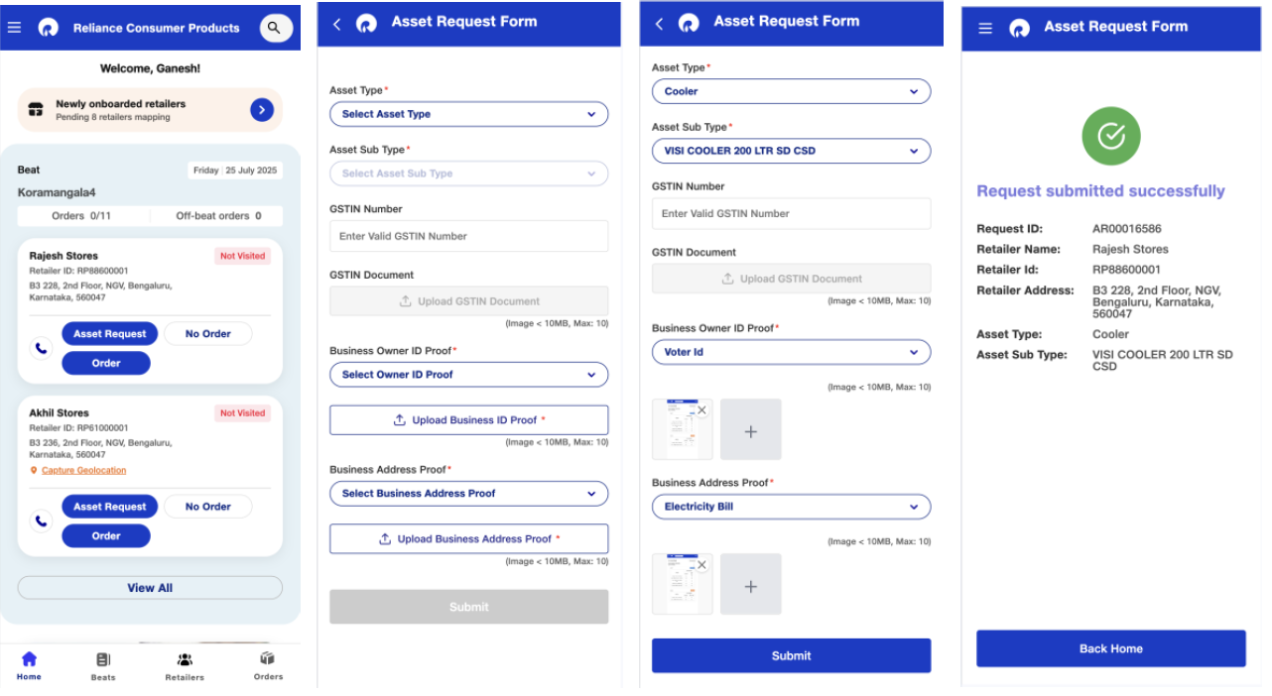

2. First-Level Approval – ASE/ASM
- The ASE and ASM mapped to the respective FOS/CSO can view all asset requests raised by the FOS/CSO under the Asset Dashboard tab.
- ASE/ASM can search for a retailer using the retailer’s name, mobile number, city, or the current status of the request.
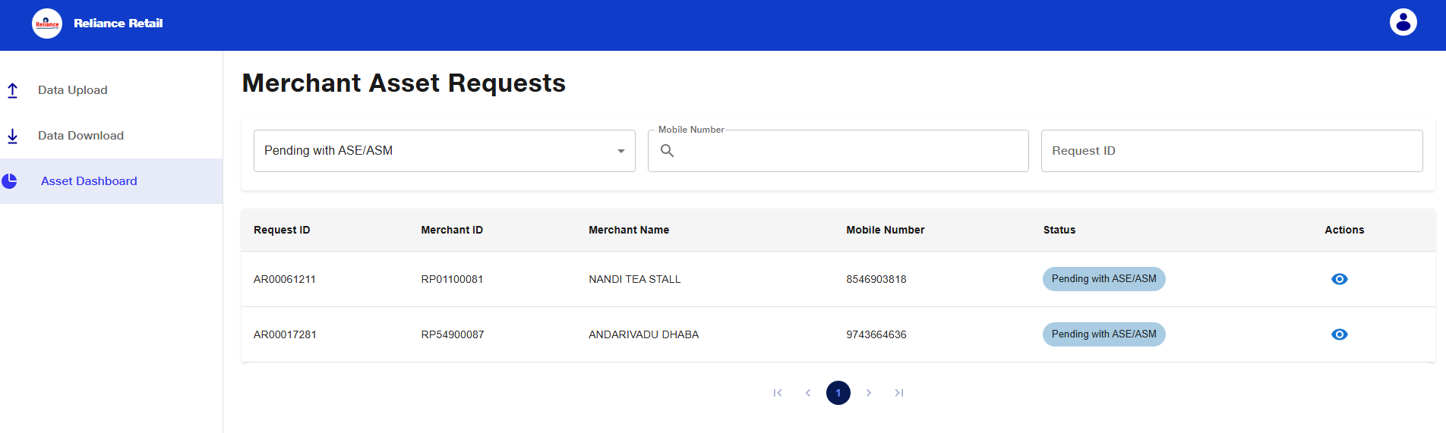

- The ASE/ASM can view the name of the CSO who raised the request.
- The ASE/ASM may approve or reject the request, and if required, they can modify the asset category or asset subtype before taking further action.
- The asset request can be validated and approved by either the ASE or the ASM.
- If the request is rejected, the ASE/ASM must select an appropriate rejection reason.
Note: If the retailer is an existing customer and the SAP Customer Code has already been created, the request will be automatically marked as Compliant and forwarded directly to the CDE Executive for service provider allocation.
URL : https://jio-dms-service.extensions.jmpx3.de/login

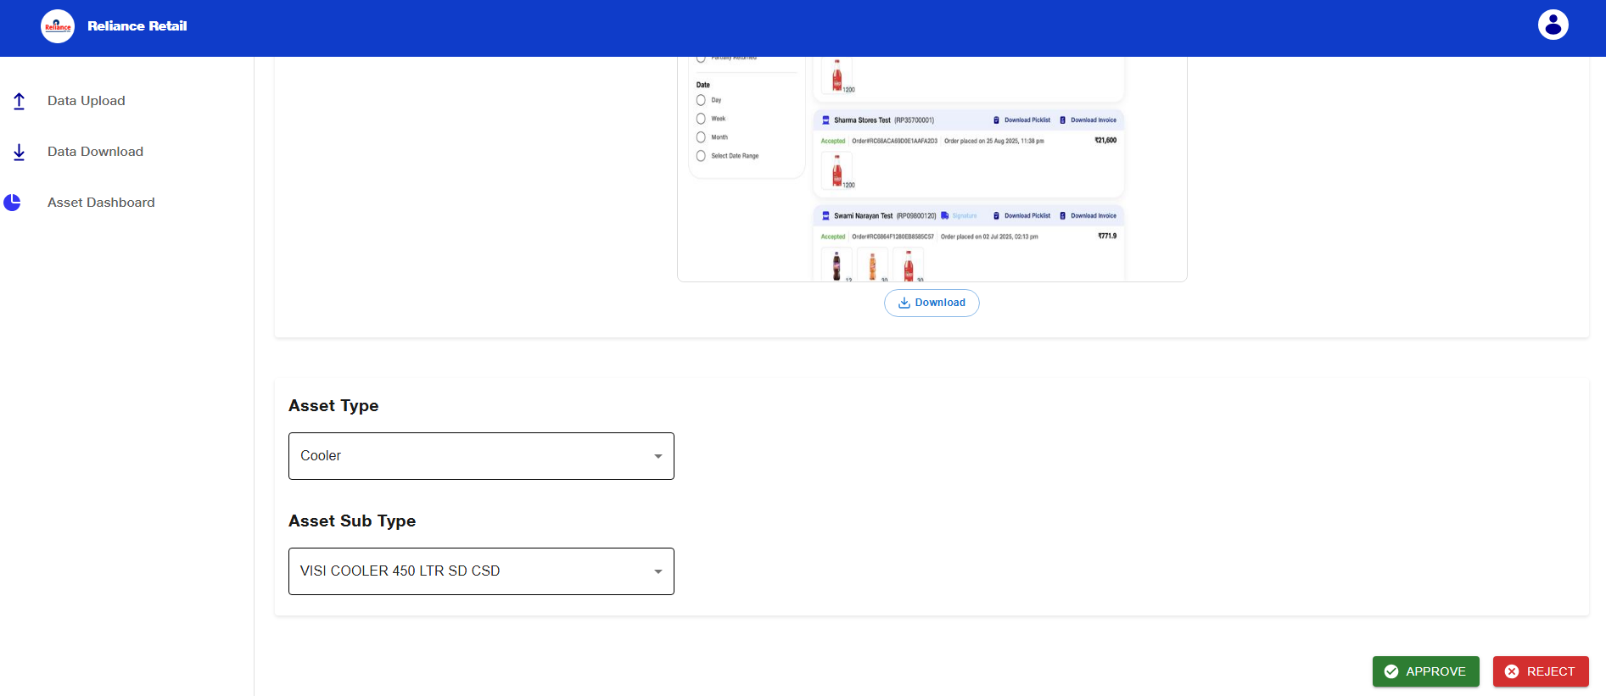

3.Compliance Check – BPO Customer

Scenario: 1
If SAP Customer Code is not Generated for the Retailer,
- The BPO Customer reviews all ASE/ASM-approved requests, which appear in the system with the status “Pending with BPO Customer.”
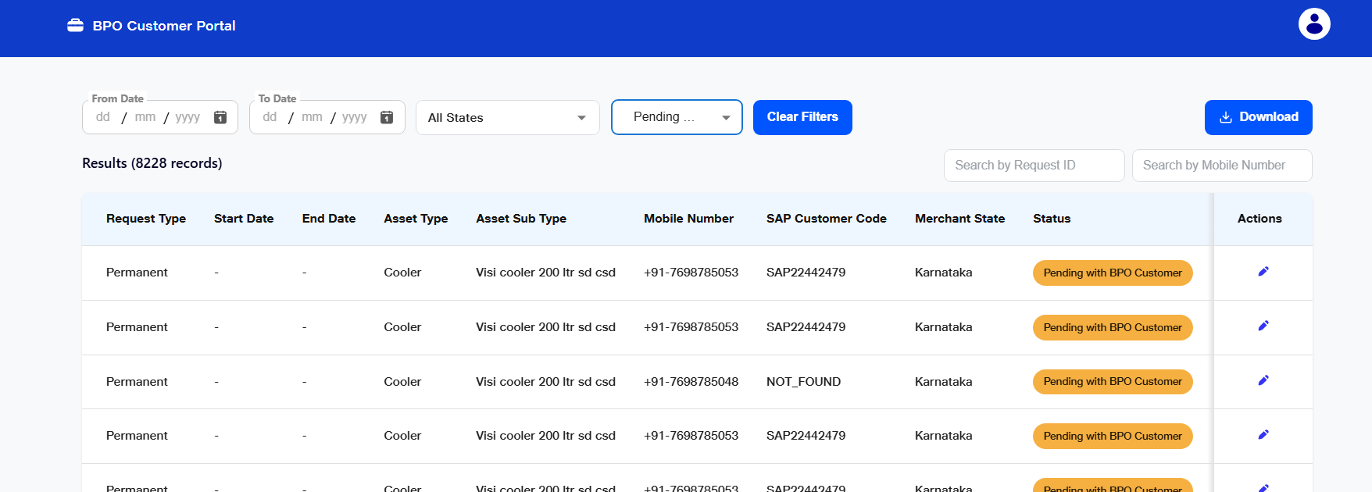

- The BPO Customer verifies the accuracy of the retailer’s data and the documents uploaded in the request.
- If all documents are correct, the BPO Customer marks the request as Compliant.
- If the request is Non-Compliant, the reason will be displayed based on the data available in the file downloaded from the Download tab.
- Once the corrected documents are re-uploaded, the BPO Customer revalidates the request and marks it as Compliant.
- After the request is marked as Compliant, the BPO Customer must approve the request so that it moves forward to the CDE Executive for the next stage of processing.
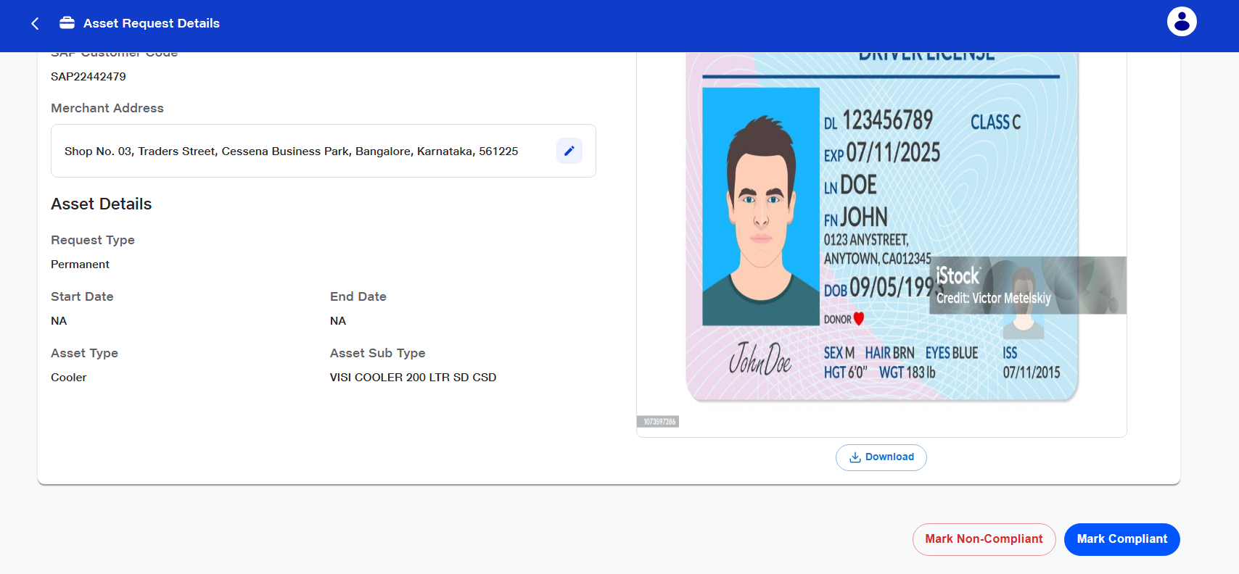
- Once the request is marked as Compliant, the system triggers the SAP Customer Code creation process. If a customer code already exists for the retailer, the same code will be used; if not, a new SAP Customer Code will be generated automatically.
Scenario: 2
If the SAP Customer Code was Already Generated for the Retailer,
- After the ASE/ASM approval, the request will be automatically marked as Compliant and will directly move to the CDE Executive for further processing.
URL : https://jio-dms-service.extensions.jmpx3.de/asset-management-login

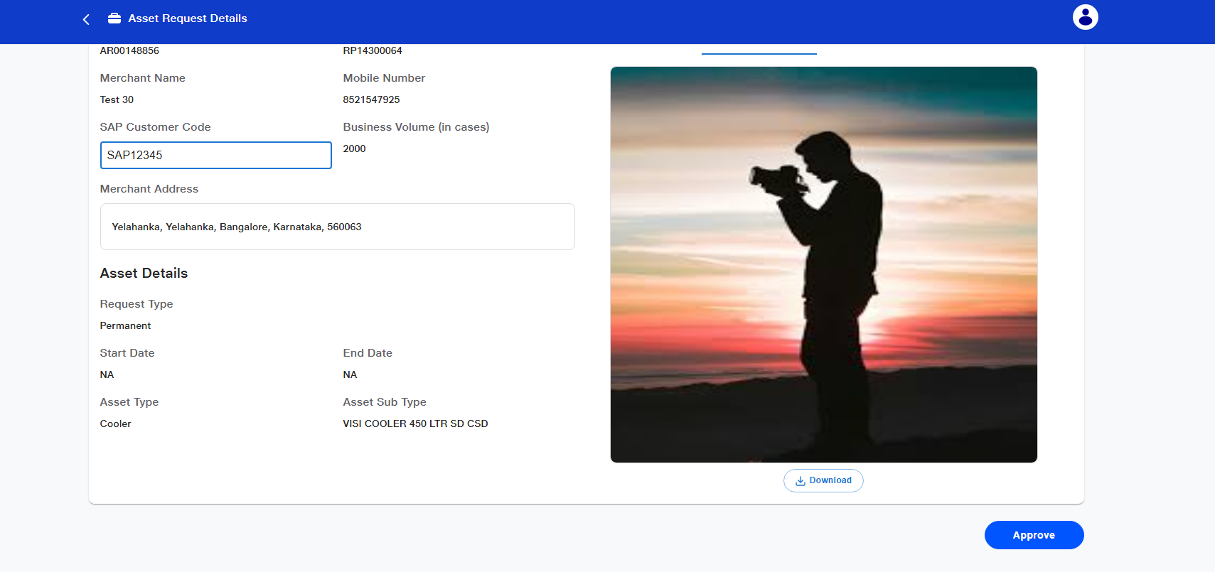

4. Service Provider Allocation – CDE

- The CDE Executive processes all requests that have been approved by the BPO Customer.
- He/She downloads each request that appears in the system with the status “Pending with CDE.”

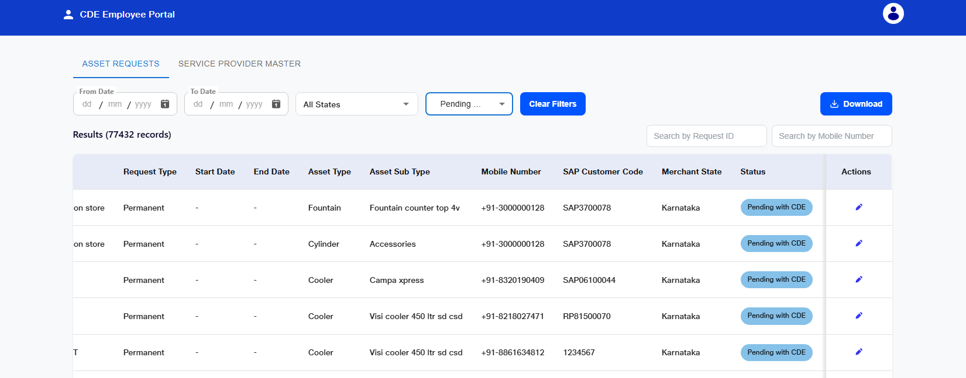

- The CDE can filter asset requests based on creation date, asset status, and the state from which the request has been received.
- Based on the retailer’s location and the service provider’s operational capacity, the CDE Executive assigns the appropriate Service Provider and enters the corresponding Service Provider ID in the designated field.
- If required, the CDE may modify the asset type or asset subtype before proceeding.
- The CDE will validate the entered details to identify any errors such as incorrect asset types, invalid service provider IDs, or mismatched information.
- Once all details are verified to be accurate, the CDE Executive must click the Approve button located at the bottom of the screen.
- After approval, the request will be forwarded to the assigned Service Provider for the next step in the workflow.

URL : https://jio-dms-service.extensions.jmpx3.de/asset-management-login
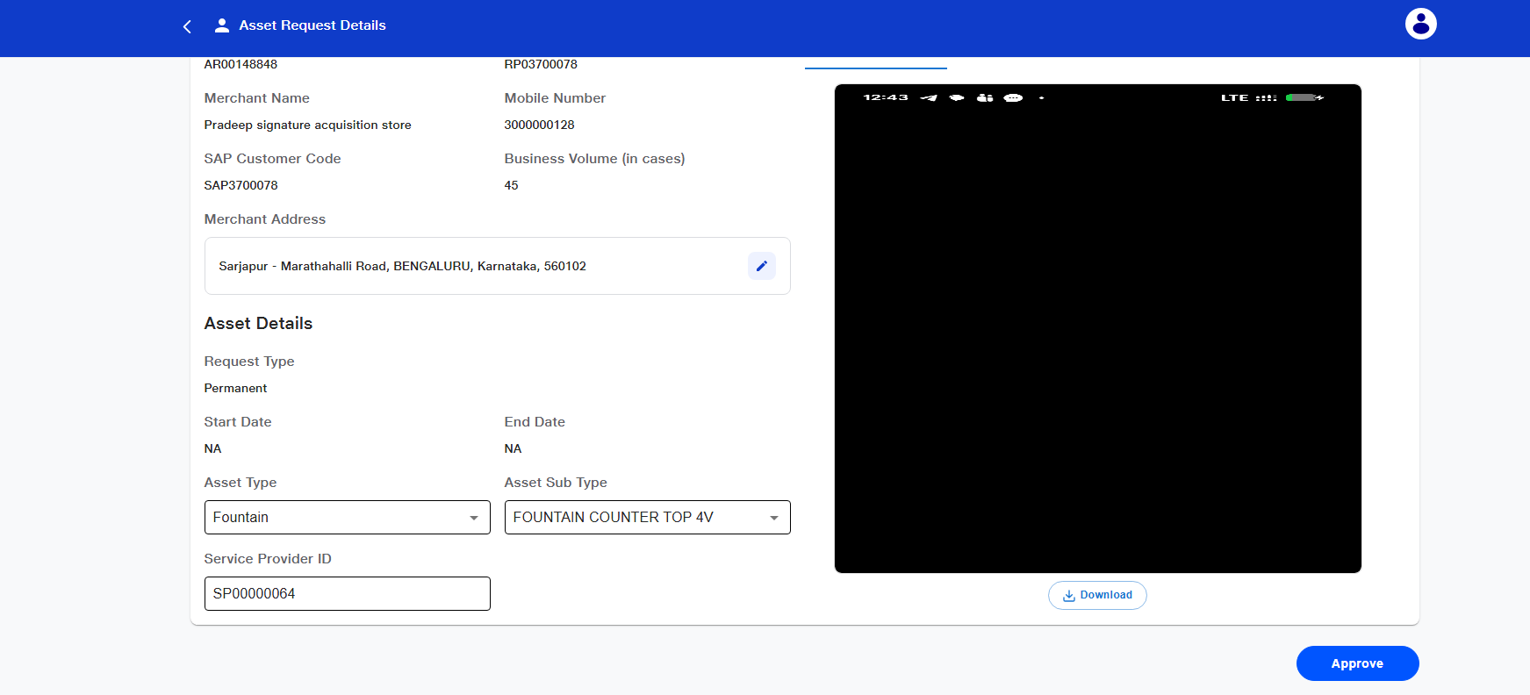

5. Execution Setup – Service Provider
- In the Service Provider Portal, the Service Provider filters all requests by selecting the status “Pending with Service Provider.”
- Alternatively, the Service Provider can filter requests using additional criteria such as date created, asset status, and the state from which the request has been received.
- The Service Provider must download the GRN Template and upload the details of the asset that is being allocated.
- The GRN details to be entered include:
    - Site Code
    - Asset Type
    - Asset Subtype
    - Asset Model
    - Asset Serial Number
    - Manufacturer Serial Number

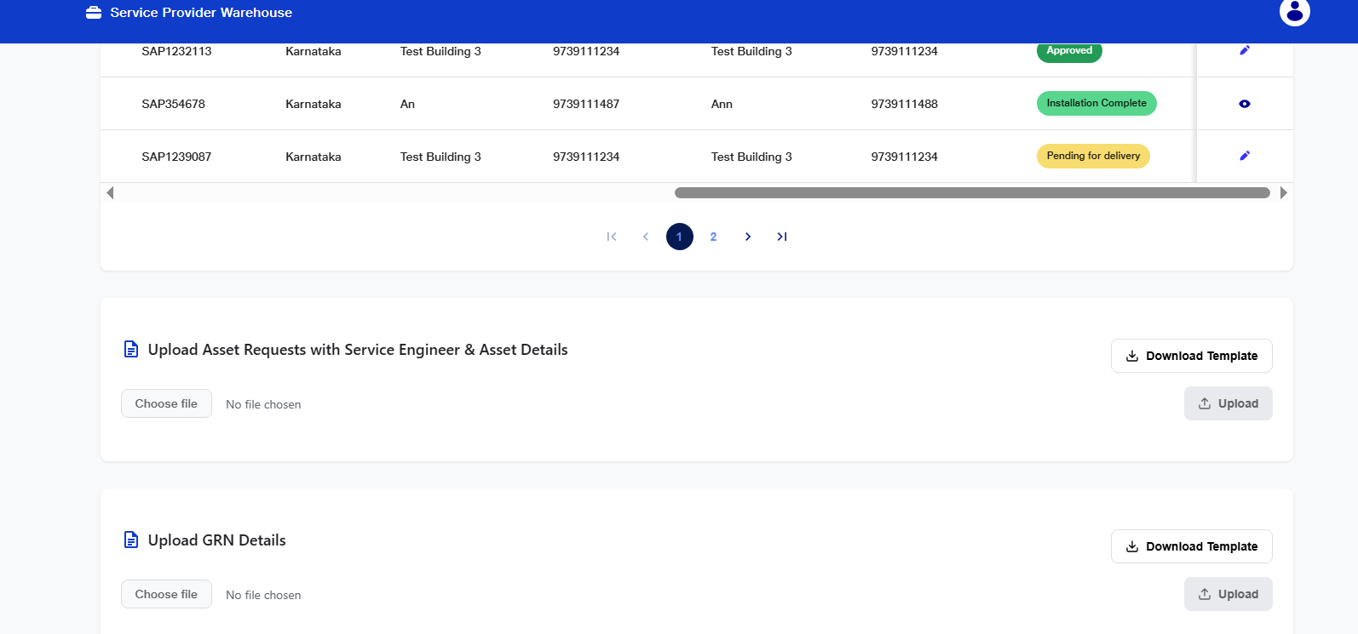
- Once the GRN is completed, the corresponding asset quantity is automatically deducted from the site storage.
- After the GRN details are successfully updated, the Service Provider must re-enter the Asset Serial Number in the designated field and approve the request.
- Upon approval, the system automatically triggers the CCO creation process.
- After this stage, the request moves to the BPO CCO team, where the CCO number will be updated in the system.
URL : https://jio-dms-service.extensions.jmpx3.de/asset-management-login
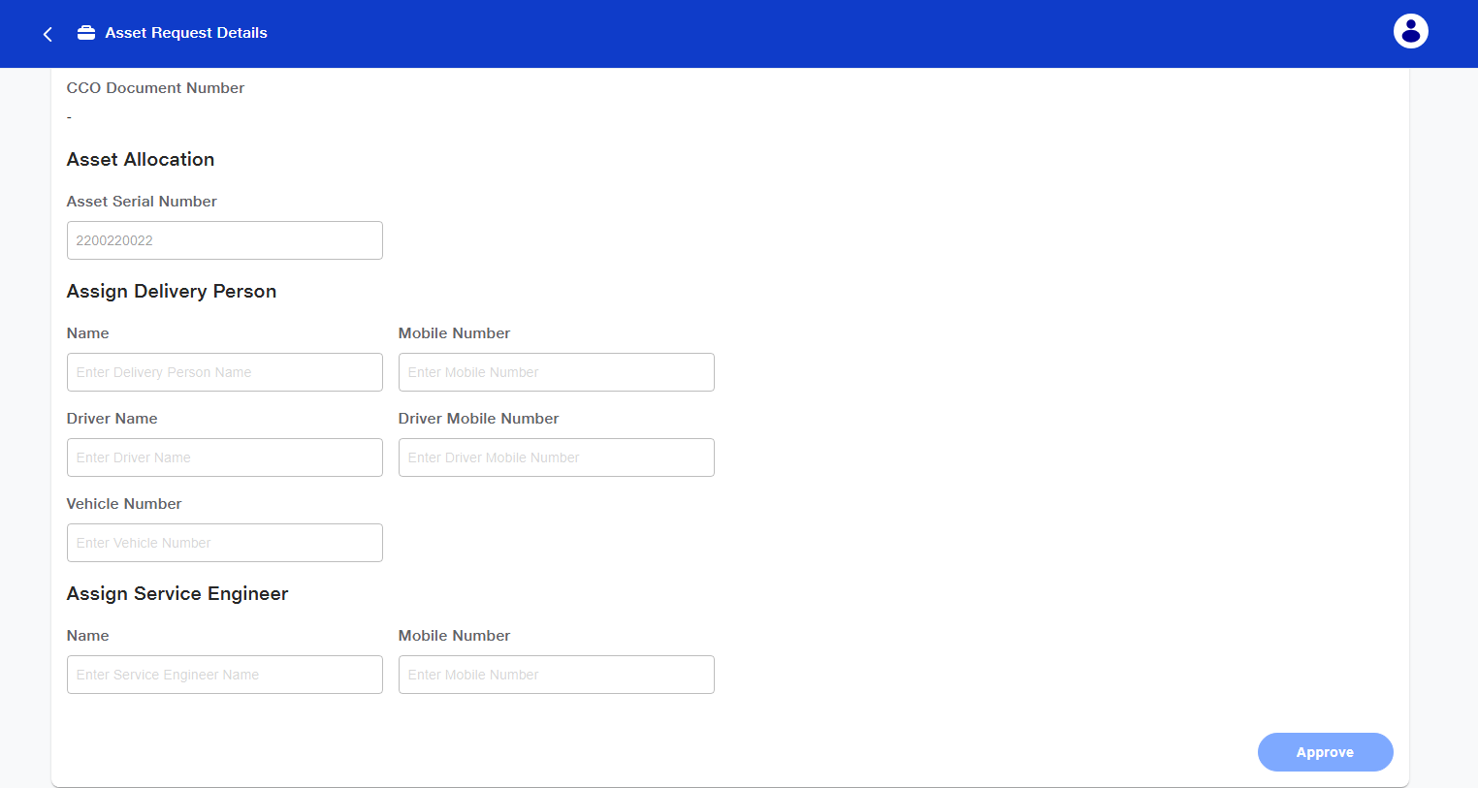

6. CCO Generation – BPO CCO
- In BPO CCO Portal, “Pending for CCO creation” status requests will be displayed.
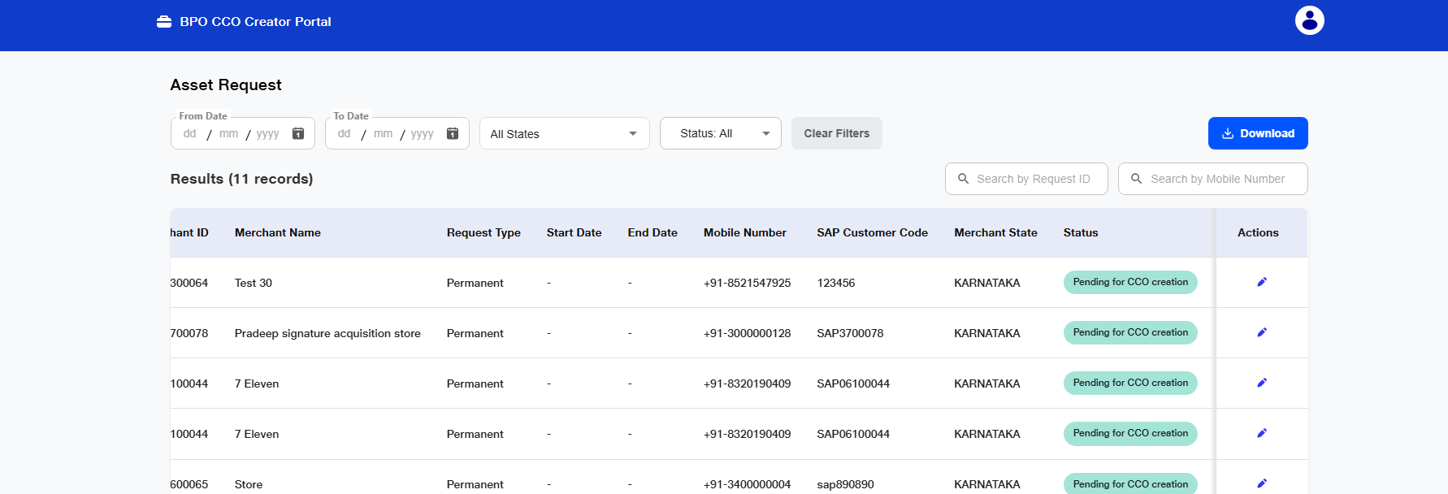

- In the respective request, enter the generated CCO number in the CCO Document Number field and approve the request.
- Once the approval is completed, the request automatically moves to the BPO Delivery team for delivery challan creation.
URL : https://jio-dms-service.extensions.jmpx3.de/asset-management-login
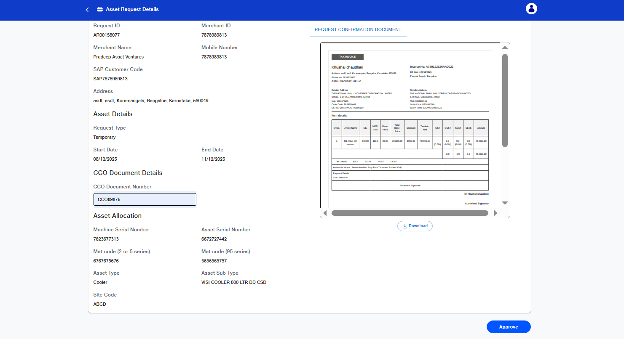

7. Dispatch Documentation – BPO Delivery

- In the BPO Delivery Portal, all requests with the status “Pending for Delivery Challan Creation” will be displayed.
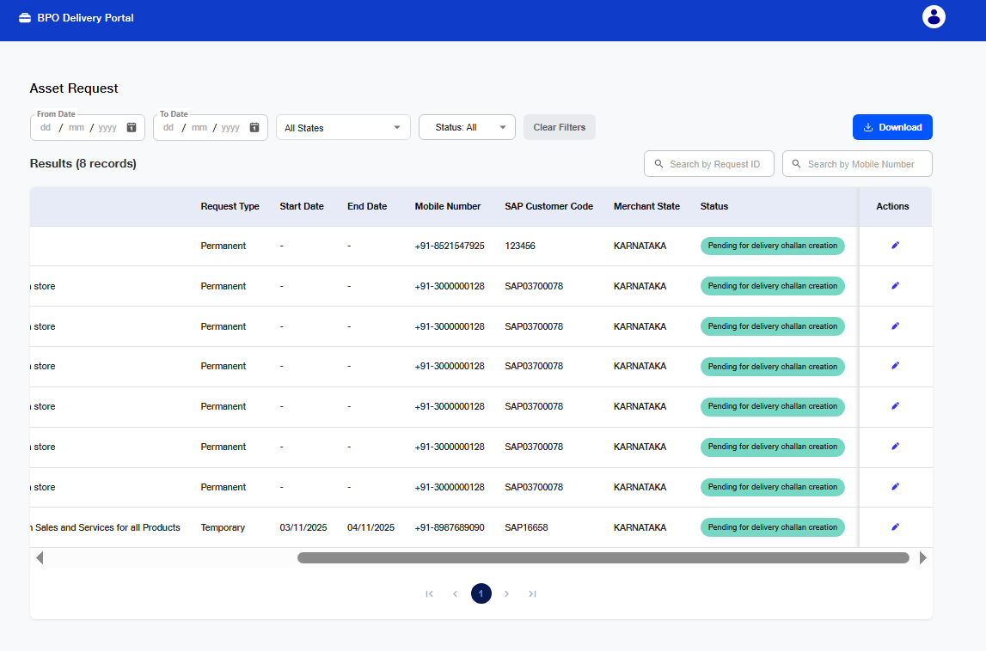
- The required dispatch details must be entered, including:
    - Delivery Contact Person
    - Delivery Challan Number and Date
    - PGI (Post Goods Issue) Number
    - Shipment Number
    - E-way Bill Number
- After entering the details, five copies of the Delivery Challan and the E-way Bill for the shipment must be uploaded in either PDF or image format.
- Once all required documents are uploaded, the BPO Delivery team approves the request and proceeds to the next stage of the workflow.
URL : https://jio-dms-service.extensions.jmpx3.de/asset-management-login

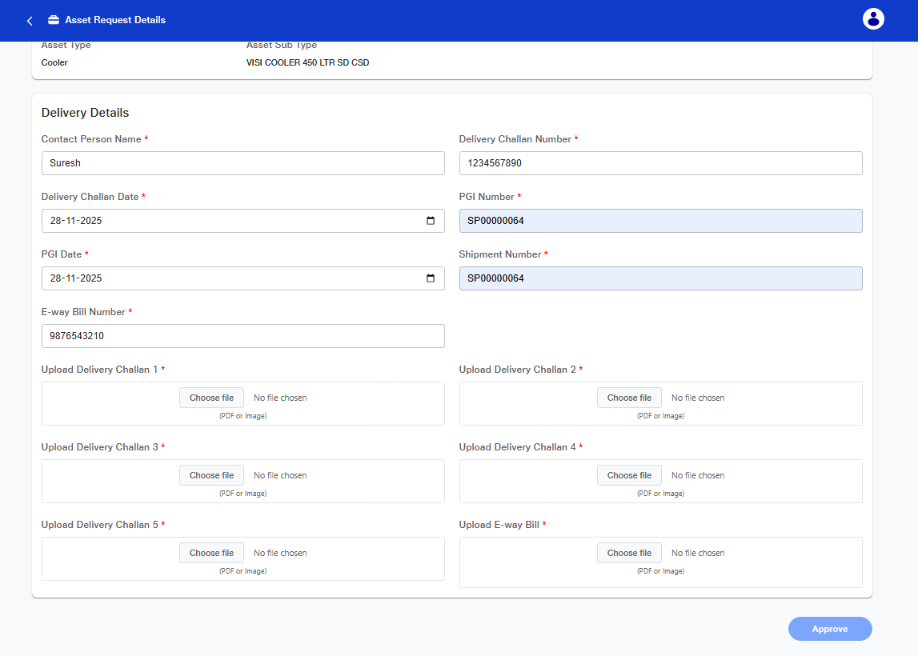

8. Delivery and Installation Allocation – Service Provider
- In Service Provider Portal, “Pending for Delivery agent allocation” status requests will be displayed.
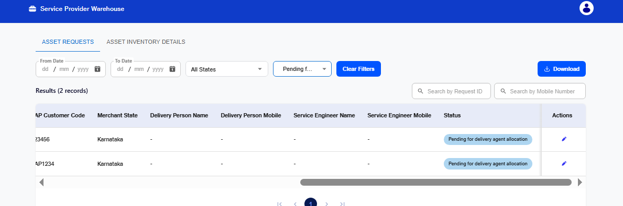
- The Service Provider assigns the Delivery Agent and Driver who will be responsible for delivering the asset to the customer’s outlet.
- The Service Provider also assigns the Service Engineer who will carry out the installation of the asset at the retailer location.
- Once all partners are assigned, the Service Provider clicks the Approve option to confirm the assignments.
- After approval, the assigned Driver and Service Engineer receive notifications regarding their respective delivery and installation tasks through the DMS Mobile Application.
- Once the delivery and installation partners are assigned, the asset is loaded and handed over to the designated Delivery Partner for transportation to the retailer.
URL : https://jio-dms-service.extensions.jmpx3.de/asset-management-login
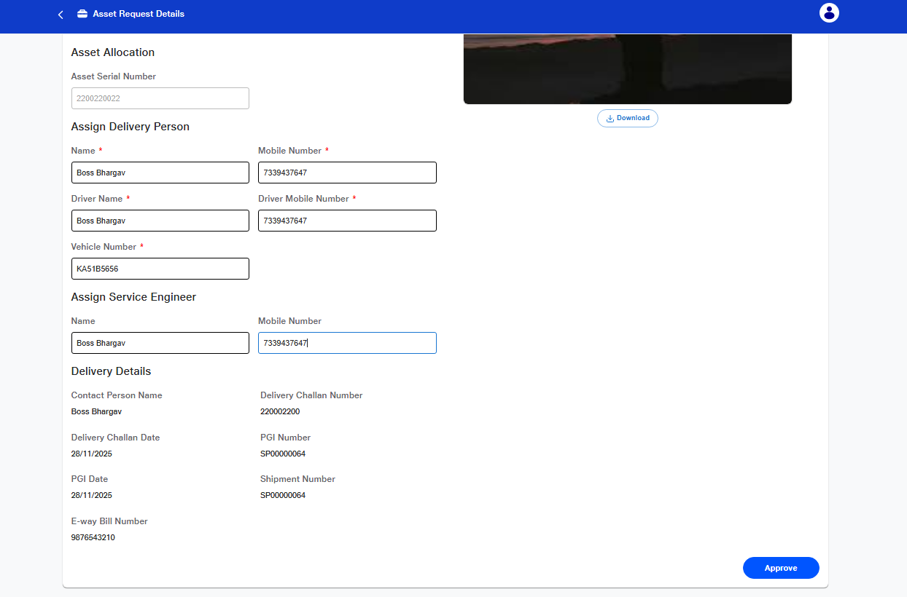

8. Cooler Delivery – Delivery Person
- The Delivery Partner logs into the mobile application using their registered mobile number.
- The Delivery Partner can view all orders assigned to them within the application.
- After delivering the correct asset to the retailer’s outlet, the Delivery Partner must mark the request as Delivered in the system.
- Following the delivery, the Delivery Partner uploads the Proof of Delivery (POD) and completes OTP verification using the OTP sent to the retailer’s registered mobile number.
- Once the OTP verification is successfully completed, the delivery is officially confirmed in the system.
- After confirming delivery, the retailer hands over the signed Asset Agreement to the Delivery Partner, which will later be used for documentation processing by the BPO Verifier.
URL: https://rcpl.jmpx3.de/

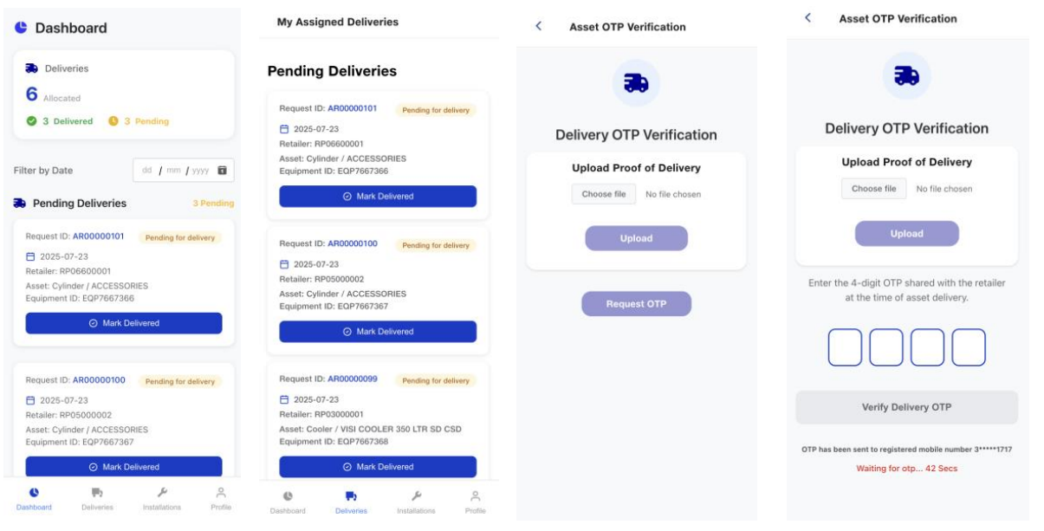

9. Cooler Installation – Service Engineer
- The Service Engineer will log in to the mobile application using their registered mobile number.
- The Service Engineer will view the orders assigned to them within the application.
- Once the Delivery Partner has marked the delivery as complete, the Service Engineer will visit the respective outlet.
- After completing the installation, the Service Engineer will mark the request as Installed in the application.
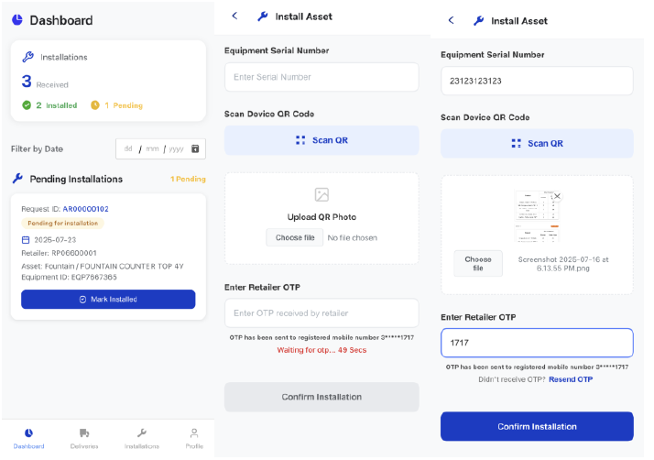
- Upon marking the request as Installed, the Service Engineer must either scan or manually enter the asset number and complete the Installation Checklist that appears.
- The Service Engineer will then obtain the OTP from the retailer and confirm the successful installation of the asset.
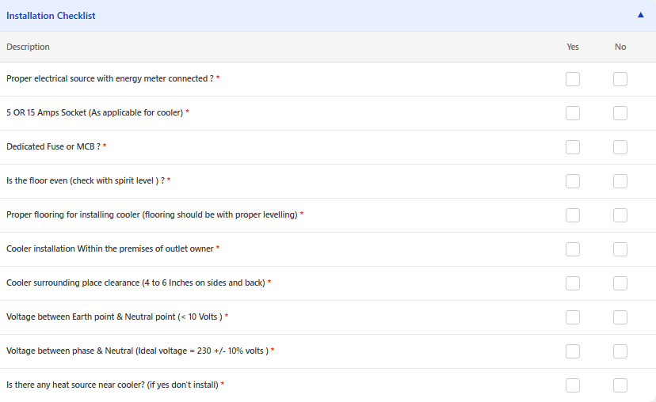

10. Agreement Upload – Service Provider
- Once the delivery and installation are completed, the Service Provider will upload the asset agreements to the portal.
- The Service Provider will filter requests with the status “Installation Completed” to identify requests requiring document upload.
- Upon selecting a specific request, the Service Provider will choose the relevant agreement copy and upload it using the dropdown option provided at the bottom of the page.
- After selecting the agreement, the Service Provider will click “Upload Agreement Copy” to complete the upload process.
- Once the upload is successful, the request status will automatically update to “Agreement Uploaded”.
- The request will then be routed to the BPO Document Verifier for agreement verification.
URL : https://jio-dms-service.extensions.jmpx3.de/asset-management-login

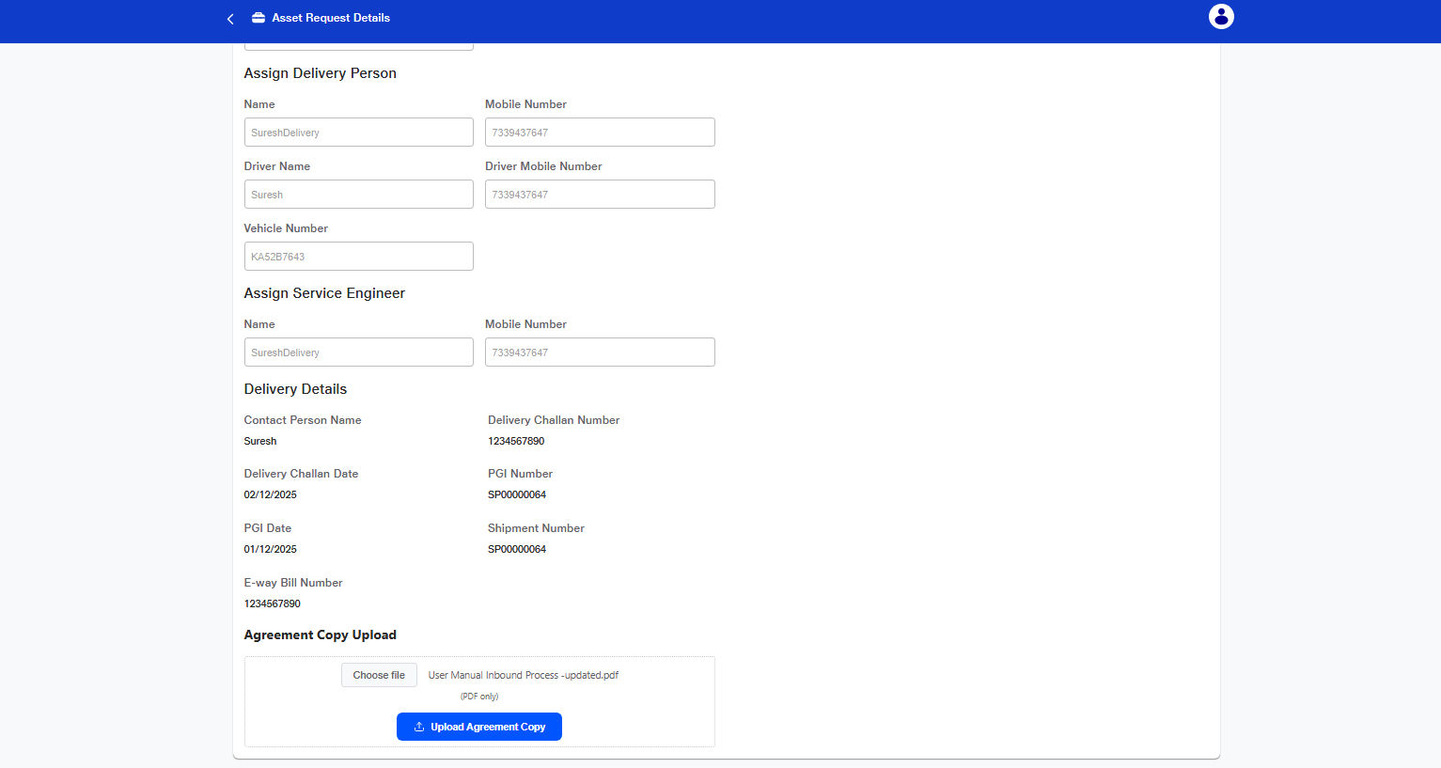

10. Final Agreement Verification – BPO Verifier

Scenario: 1
- The BPO Document Verifier will filter requests with the status “Agreement Uploaded”.
- The BPO Document Verifier will review and verify the agreement uploaded by the Service Provider.
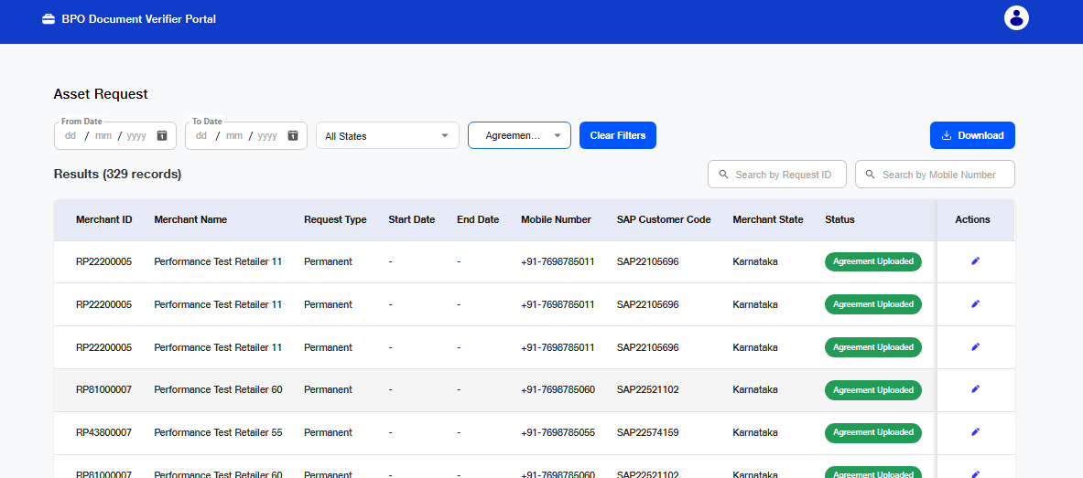

- If the uploaded agreements are validated and found to be correct, the BPO Document Verifier will approve the request.

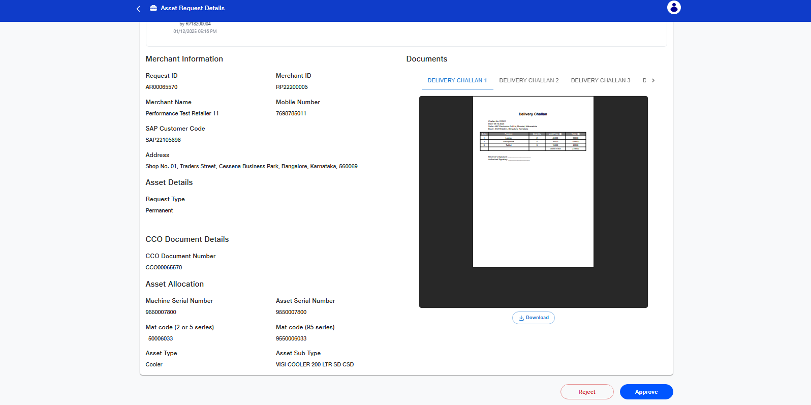
- Upon request approval, the customer will receive a feedback call to share their experience regarding the asset request and installation process.
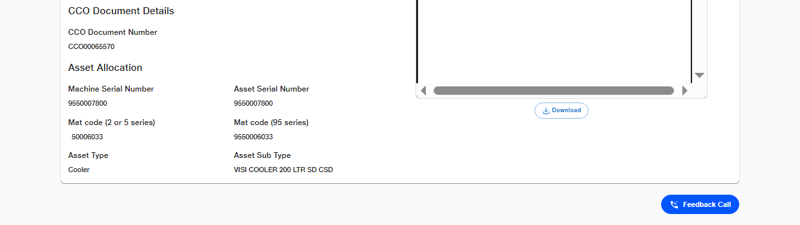

- The BPO Document Verifier will manually enter the customer feedback into the system, completing the final verification required for request closure.
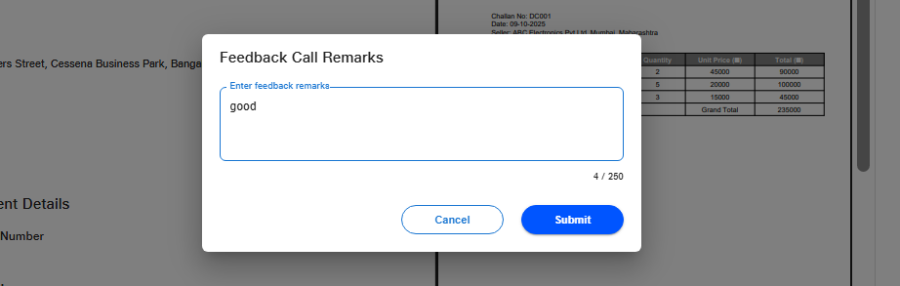
Scenario: 2
- If the details in the uploaded agreement are incorrect, the BPO Document Verifier will mark the agreement as Rejected.
- The rejected agreement request will return to the Service Provider, who must correct the details and re-upload the agreement in the portal.
- Once the agreement is correctly uploaded, the standard verification process will follow as outlined above.
URL : https://jio-dms-service.extensions.jmpx3.de/asset-management-login


